CyberNova

Sprint 2 Project Documentation
For
BusNova Bus Management Version 2.0


Submission date: 15 September 2026
For: Mr. D. Boucher

Declaration of Work:
We, CyberNova, declare that:
- The system developed is our original work and has not in part been submitted for the purposes of final assessment for any other 3rd year project module,
- We have the permission to use images shown in our system and have created our own logos that are used in our system,
- Where we have made use of programming assistance, we acknowledge this fact in the acknowledgements section below,
- We did not outsource the building of the entire system to a third party.
Group Members and Roles:
Name and Surname | Student Number | Role(s) | Electronic Signature
Anesipho Kalazana | 202327653 | BA
Elihle Nteyi | 202316017 | BA
Esethu Mtose | 224072208 | BA
Nadia Mpohlekana | 224104608 | PM; DO | 
Olebogeng Gumbu | 224111100 | PR
Simanye Siximba | 224017307 | PR | 
Yonwaba Mgqulwana | 224090097 | BA; DO
Role Key:
PM: Project Manager (only one member can be PM at any given time)
BA: Business Analyst
DO: Documenter
PR: Programmer
A team member can complete multiple roles.

Acknowledgements:
We would like to thank:
1.Lecturers:
Business Analysis: Assoc. Prof R. Piderit | rpiderit@ufh.ac.za
Databases: Dr V. Funda | vfunda@ufh.ac.za
Programming: Mr T. Breetzke | tbreetzke@ufh.ac.za

- Our Mentor: Anelisa Gobingca

Table of Contents
System Matrix 3
System Overview 5
1. Section A: Business Process Description 6
1.1. Use Case Diagram 7
1.2. Use Case Narrative 7
1.2.1. Register Use Case Narrative 8
Activity Diagram 1: Register 8
1.2.2. Login Use Case Narrative 9
Activity Diagram 2: Login 10
1.2.3. Register Bus Use Case Narrative 11
Activity Diagram 3: Register Bus 13
1.2.4. Create Routes Use Case Narrative 13
Activity Diagram 4: Create Routes 14
1.2.5. Assign Routes Use Case Narrative 15
Activity Diagram 5: Assign Routes 16
1.2.6. View Assigned Routes Use Case Narrative 17
Activity Diagram 6: Assigned Routes 18
1.2.7. View Maintenance Schedule Use Case Narrative 19
Activity Diagram 7: View Maintenance Schedule 20
2.Section B: Data Modelling Requirements 21
2.1. Entity Relationship Diagram 22
2. 2. Attribute Framing 22
2.2.1. Fleet Manager 23
2.2.2. Passengers 23
2.2.3. Drivers 23
2.2.4. Maintenance Staff 24
2.2.5. Buses 24
2.2.6. Routes 25
2.2.7. Route Assignments 25
2.2.8. Maintenance Logs 26
2.2.9. Fuel Logs 26
2.2.10. Tickets 27
3.Section C: Systems Design Requirements 27
3.1. Windows Navigation Diagram 28
3.2. Screen Design Specification 29
3.2.1. Screen 01: Home Page 29
3.2.2. Screen 02: Register 29
3.2.3. Screen 03: Login 30
Table 11: SC3 - Screen Narrative and Controls 31
3.2.4. Screen 04: Register Bus 31
3.2.5. Screen 05: Create Routes 32
3.2.6. Screen 06: Assign Routes 33
3.2.7. Screen 07: View Assigned Routes 34
Sprint Backlog - Sprint 1 36
Risk Log 39
Sprint Progress Report 39

System Matrix
Business Process | Reference | Use Case | Table | Screen | Report
Register an account | UC1 | Register | User | SC2 | List of Registered Users
Login to the system | UC2 | Login | User | SC3 | Login Activity Report
Register buses | UC3 | Register bus | Bus | SC4 | Registered Buses Report
Create routes | UC4 | Create route | Route | SC5 | Route List Report
Assign routes | UC5 | Assign route | Route Assignment | SC6 | Route Assignment Report
Monitor bus operations | UC6 | Monitor operations |  | SC8 | Bus Operations Report
Review reports on route completion | UC7 | View reports | Route | SC9 | Route Completion Report
Review fuel efficiency | UC8 | Review fuel | FuelLog | SC10 | Fuel Efficiency Report
View assigned routes & schedule | UC9 | View assigned routes | RouteAssignment | SC7 | Driver Schedule Report
Report fuel usage | UC10 | Report Fuel | FuelLog | SC11 | Fuel Usage Report
Report maintenance issues | UC11 | Report Issue | MaintenanceLog | SC12 | Maintenance Issues Report
Update trip status | UC12 | Update Status |  | SC13 | Trip Status Report
View bus routes | UC13 | View Routes | Route | SC14 | Route Report
Check availability | UC14 | Check Availability | Bus | SC15 | Bus Availability Report
Purchase ticket | UC15 | Purchase Ticket | Ticket | SC16 | Ticket Sales Report
Receive confirmation email | UC16 | Receive Confirmation | Ticket | SC17 | Booking Confirmation Report
View maintenance schedule | UC17 | View Maintenance Schedule | MaintenanceLog | SC18 | Maintenance Schedule Report
Log reports and servicing activities | UC18 | Log Service Activities | MaintenanceLog | SC19 | Service History
Update vehicle condition | UC19 | Update Vehicle Status | MaintenanceLog, Bus | SC20 | Vehicle Condition Report
Receive alerts for upcoming and overdue services | UC20 | Receive Maintenance Alerts | MaintenanceLog | SC21 | Maintenance Alert Report
Adding employees to the system | UC21 | Register employees |  | SC22 | N/A
Table 1: BusNova System Matrix

System Overview
BusNova is an integrated Bus Management System designed to centralise and streamline the management of bus fleet operations, transportation services and vehicle maintenance. The system provides role-based functionality for Fleet Managers, Bus Drivers, Passengers and Maintenance Staff, enabling users to perform activities according to their responsibilities. These include user registration and authentication, bus registration, route creation and assignment, trip-status updates, passenger ticket purchasing, fuel monitoring, maintenance management and operational reporting.
The system connects these processes through a centralised database containing information relating to users, buses, routes, route assignments, tickets, fuel logs and maintenance records. Fleet Managers can allocate available buses and drivers to routes while the system validates availability to prevent scheduling conflicts. Drivers can access assigned routes and schedules, while Maintenance Staff can monitor servicing schedules, record maintenance activities and receive alerts for overdue services. Passengers can view routes, check availability, purchase tickets and receive booking confirmations.
BusNova supports Sustainable Development Goal 9 (Industry, Innovation and Infrastructure) by digitally integrating and improving transportation infrastructure management. It supports SDG 11 (Sustainable Cities and Communities) by facilitating organised and accessible public transportation services. The system also contributes to SDG 12 (Responsible Consumption and Production) through fuel-usage and fuel-efficiency monitoring, as well as preventative vehicle maintenance. These functions collectively promote more efficient resource utilisation and sustainable transport operations.
Overall, BusNova provides a unified platform that improves operational coordination, information accuracy, fleet visibility and decision-making across the bus management environment.

1. Section A: Business Process Description

1.1. Use Case Diagram
Figure 1: BusNova Use Case Diagram

1.2. Use Case Narrative

1.2.1. Register Use Case Narrative
BusNova
Use Case Specification
Use Case Id | UC1
User Case Name | Register
Actor(s) | Passenger
Brief Description | This use case allows a new user to register an account by entering their personal details. The system validates the information, checks whether the email address already exists, encrypts the password, stores the user's information in the database, creates the account, and redirects the user to the login page upon successful registration.
Main Flow of Events | Actor |  | System
Main Flow of Events | - Opens the Registration page.  - Enters registration details (e.g., name, surname, email, password, confirm password).  3. Clicks the Register button. |  | 1,2. Displays the registration form.  2.1. Validates the entered information.  2.2. Checks whether the email address validation in the database.  3.1. Displays a registration success message if Valid.  3.2. Display a validation error when not valid.  3.3. Redirects the user to the Login page.
Alternative Flows of Events | If required fields are missing or invalid, the system displays validation error messages and returns the user to the registration form to correct the information.
Created by | Elihle Nteyi | Last Modified by |  | Yonwaba Mqulwana
Date | 01 August 2026 | Date |  | 05 August 2026
Table 2: Register Use Case Narrative

Activity Diagram 1: Register
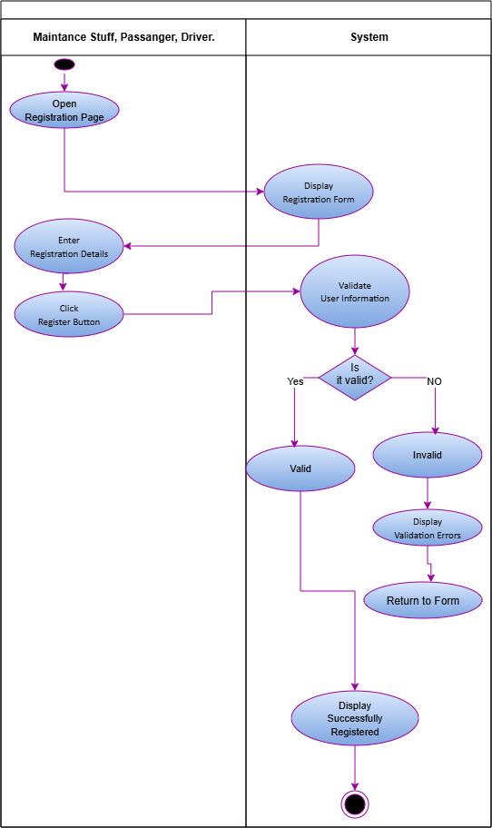
Figure 2: Register Activity Diagram

1.2.2. Login Use Case Narrative
BusNova
Use Case Specification
Use Case Id | UC2
User Case Name | Login
Actor(s) | Fleet manager, Driver, Passenger, Maintenance Staff
Brief Description | The user enters their details (username and password) to access the system.
Frequency of use | Daily, whenever a user wants to access the system.
Preconditions | The user has a registered account.
Main Flow of Events | Actor |  | System
Main Flow of Events | 1. Clicks Login.  2. Enters email and password.  3. Click “Login” |  | 1.1 Display login page.  3.1 Verify credentials  3.2 Grant access/Display error message and redirects back to input  3.3 Display User  3.4 End use case
Alternative flow of events | 1.User enters an email that is not registered.  2.System determines that no account exists.  3.System displays "Account does not exist. Please register first."  4.User registers or returns to the login page.
Postconditions | The user has successfully logged into the system and taken to their dashboard.
Special requirements | Passwords must be encrypted, login credentials must be validated, and access must be based on the user's role.
Created by | Yonwaba Mgqulwana | Last Modified by |  | Simanye Siximba
Date | 30 July 2025 | Date |  | 28 August 2026
Table 3: Login Use Case Narrative

Activity Diagram 2: Login
Figure 3: Login Activity Diagram

1.2.3. Register Bus Use Case Narrative
BusNova
Use Case Specification
Use Case Id | UC3
User Case Name | Register Buses
Actor(s) | Fleet Manger
Brief Description | A fleet manager registers a new bus into the system by providing bus details such as registration number, model, manufacturer, seating capacity and fuel type. After successful registration, the bus becomes available for route assignment and scheduling.
Frequency of use | Low
Preconditions | Fleet Manager is logged in with an active session (role-based access, no separate permission check).
Main Flow of Events | Actor |  | System
Main Flow of Events | 1. Selects “Register Buses”.  2. Enters the bus details.  3. Clicks “Save/Register”. |  | 1.1 Displays an empty bus registration form.  3.1 Validates required fields and checks registration number uniqueness.  3.2 Saves the bus record and displays a confirmation message. “Bus registered successfully”.
Alternative Flows of Events | 3.1.1 If required fields are missing or invalid, the system highlights the errors and remains on the form.  3.1.2 If the registration number already exists, the system reminds the fleet manager to enter a different registration number.
Postconditions | New bus record is stored in the database, bus becomes available for route assignment, driver scheduling and maintenance scheduling.
Special Requirements | Registration number must be unique; seating capacity must be a positive number.
Created by | Anesipho Kalazana | Last Modified by |  | Elihle Nteyi
Date | 03 August 2026 | Date |  | 07 August 2026

Activity Diagram 3: Register Bus
Figure 4: Register Bus Activity Diagram

1.2.4. Create Routes Use Case Narrative
BusNova
Use Case Specification
Use Case Id | UC4
User Case Name | Create Routes
Actor(s) | Fleet Manager
Brief Description | Describes how the Fleet Manager defines a new bus route in the system.
Frequency of use | As needed, whenever new routes must be added or existing service areas expanded.
Preconditions | The Fleet Manager is logged into the system with valid credentials.
Main Flow of Events | Actor |  | System
Main Flow of Events | 1. Select the "Create Routes".  2. Enters the route details and adds intermediate stops.  3. Submits the route for saving |  | 1.1. Displays the route creation form.  3.1. Validates the entered data.  3.2. Checks that the route ID/name is unique.  3.3. Saves the new route to the database.  3.4. Displays a confirmation message.
Alternative Flows of Events | 3.1.1. If required fields are missing or incorrectly formatted, the system displays an error message and returns the Fleet Manager to step 3.
Postconditions | Success: A new route record is created and saved in the system database.
Special Requirements | The system must validate all route details before saving and ensure that the information complies with the database constraints.
Created by | Nadia Mpohlekana | Last Modified by |  | Anesipho Kalazana
Date | 28 July 2026 | Date |  | 07 August 2026
Table 5: Create Routes Use Case Narrative

Activity Diagram 4: Create Routes
Figure 5: Create Routes Activity Diagrams

1.2.5. Assign Routes Use Case Narrative
BusNova
Use Case Specification
Use Case Id | UC5
User Case Name | Assign routes
Actor(s) | Fleet manager
Brief Description | The Fleet Manager assigns an available bus and driver to a specific route and schedule. The system validates the availability of the selected bus and driver before saving the assignment and updating the schedule
Frequency of use | Whenever a new route needs to be assigned or an existing assignment needs to be updated
Preconditions | The Fleet Manager is logged into the system; driver must be valid before a route assignment can be performed
Main Flow of Events | Actor |  | System
Main Flow of Events | 1. Selects Assign Routes  2. Selects the route  3. Selects bus  4. Selects driver  5. Click “Assign Route” |  | 1.1 Displays routes, buses, and drivers  2.1 Displays route details  5.1 Validates bus availability  5.2 Display “Bus unavailable” and return to Select bus  5.3 Validates driver availability  5.4 Display “Driver unavailable” and return to Select driver  5.5 Save route assignment  5.6 Updates driver’s schedule  5.7 Updates bus allocation  5.8 Display confirmation message
Alternative Flows of Events | 5.1.1 If the selected bus unavailable the system shows an error message  5.2.1 If the selected driver is already assigned to another route, the system displays an error message
Postconditions | Upon completion of the route assignment process, the system saves the assignment.
Special Requirements | The system must allow only Fleet Managers to assign routes and must validate the availability of the selected bus and driver before saving the assignment.
Created by | Olebogeng Gumbu | Last Modified by |  | Yonwaba Mqulwana
Date | 29 July 2026 | Date |  | 29 August 2026

Activity Diagram 5: Assign Routes
Figure 6: Assign Routes Activity Diagram

1.2.6. View Assigned Routes Use Case Narrative
Fleet Management System
Use Case Specification
Use Case Id | UC9
User Case Name | View Assigned Routes
Actor(s) | Bus Driver
Brief Description | The Bus Driver views the routes and trip schedule assigned to them, including trip details such as route path, stops, and pickup/drop-off times.
Frequency of use | Daily
Preconditions | 1. The Bus Driver has a registered account and is logged into the system.  2. Routes/trips have been assigned to the driver.
Main Flow of Events | Actor |  | System
Main Flow of Events | 1. Bus Driver logs in.  2. Bus Driver navigates to "My Schedule" / "Assigned Routes".  3. Bus Driver selects a route/trip to view further details. |  | 1.1 Authenticate the user.  2.1 Retrieve and display the routes and trip schedule assigned to the driver.  3.1 Display detailed trip information (route path, stops, pickup/drop-off times, assigned bus).
Alternative Flows of Events | 1. No routes/trips have been assigned to the driver → System displays "No routes assigned".
Postconditions | The Bus Driver has viewed their assigned routes and trip schedule. No data is modified by this use case.
Special Requirements | Schedule information must reflect real-time updates; driver view must be usable on mobile devices.
Created by | Siximba Simanye | Last Modified by |  | Yonwaba Mqulwana
Date | 03 August 2026 | Date |  | 07 August 2026
Table 7: View Assigned Routes Use Case Narrative

Activity Diagram 6: Assigned Routes
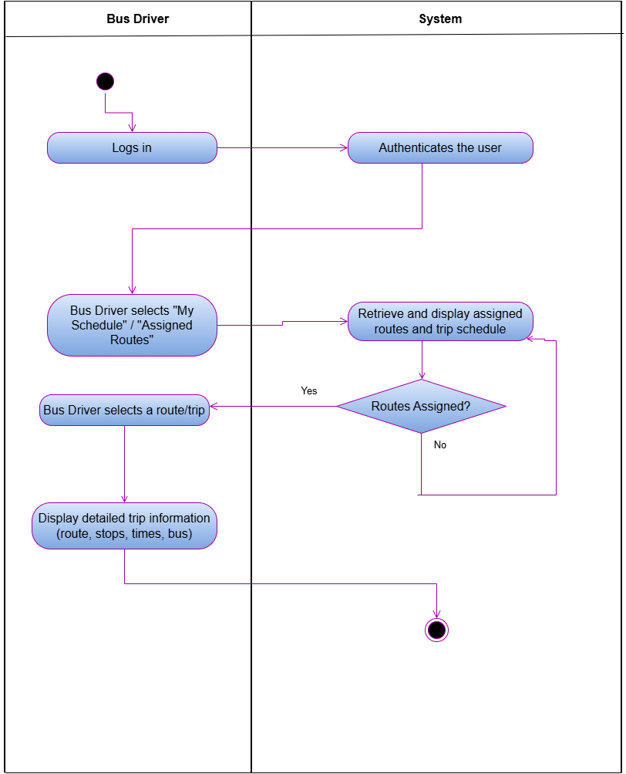
Figure 7: Assigned Routes Activity Diagram

1.2.7. View Maintenance Schedule Use Case Narrative
Fleet Management System
Use Case Specification
Use Case Id | UC17
User Case Name | View Maintenance Schedule
Actor(s) | Maintenance Staff
Brief Description | Maintenance Staff view the maintenance and servicing schedule for buses in the fleet.
Frequency of use | Medium
Preconditions | 1. Maintenance Staff has a registered account and is logged into the system.
Main Flow of Events | Actor |  | System
Main Flow of Events | 1. Maintenance Staff logs in.  2. Maintenance Staff navigates to "Maintenance Schedule".  3. Maintenance Staff filters/searches records by bus, date, or status (optional).  4. Maintenance Staff selects a bus/service record to view further details. |  | 1.1 Authenticate the user.  2.1 Display the Maintenance Schedule screen.  3.1 Retrieve and display the matching maintenance/service records.  4.1 Display detailed service information (last service date, next due date, service type, status).  4.2 If overdue, highlight the record and trigger an alert.
Alternative Flows of Events | 1. No maintenance records match the filter criteria → System displays "No maintenance records found".
Postconditions | Maintenance Staff has reviewed the maintenance schedule, with overdue services flagged. No data is modified by this use case.
Special Requirements | Schedule information must reflect real-time updates.
Created by | Siximba Simanye | Last Modified by |  | Nadia Mpohlekana
Date | 03 August 2026 | Date |  | 06 August 2026
Table 8: View Maintenance Schedule Use Case Narrative

Activity Diagram 7: View Maintenance Schedule
Figure 8: View Maintenance Schedule Activity Diagram

Review Fuel Use Case Narrative
BusNova
Use Case Specification
Use Case Id | UC8
User Case Name | Review Fuel
Actor(s) | Bus Driver
Brief Description | Allows a Bus Driver to review the fuel logs and fuel efficiency information recorded for the bus(es) they operate. The system retrieves the fuel amount, cost, odometer reading and calculated fuel efficiency for each logged entry, allowing the driver to monitor fuel usage and consumption trends over time.
Frequency of use | As needed, typically after each trip or refuelling stop.
Preconditions | 1. The Bus Driver has a registered account and is logged into the system.  2. Fuel logs exist for the bus(es) assigned to the driver.
Main Flow of Events | Actor |  | System
Main Flow of Events | 1. Selects "Review Fuel".  2. Filters/searches fuel records by bus or date.  3. Selects a fuel record to view further details. |  | 1.1 Retrieve and display the fuel logs for the bus(es) assigned to the driver.  2.1 Retrieve and display the fuel records matching the filter criteria.  3.1 Display detailed fuel information.
Alternative Flows of Events | 2.1.1. No fuel logs match the filter criteria → The system displays "No fuel records found".
Postconditions | The Bus Driver has reviewed the fuel log and fuel efficiency information. No data is modified by this use case.
Special Requirements | Fuel efficiency must be calculated accurately from the logged fuel amount, cost and distance travelled; fuel log information must reflect the most recently logged records.
Created by | Nadia Mpohlekana | Last Modified by
Date | 22 August 2026 | Date

Review Fuel Activity Diagram

Monitor Operations Use Case Narrative
Fleet Management System
Use Case Specification
Use Case Id | UC6
User Case Name | Monitor Operations
Actor(s) | Fleet Manager
Brief Description | Allows the Fleet Manager to monitor ongoing bus operations in real time from a central dashboard, including vehicle locations, trip progress, delays and driver check-ins.
Frequency of use | High (used throughout the operating day)
Preconditions | Fleet Manager is authenticated. Routes have been assigned and buses are actively operating trips.
Main Flow of Events | Actor |  | System
Main Flow of Events | 1. Navigate to the "Operations Dashboard".  2. Select a specific bus/trip to view further detail (optional). |  | 1.1 Retrieve the real-time status of all active buses and trips  1.2 Display the operations dashboard  2.1 Display detailed status for the selected bus/trip
Alternative Flows of Events | 1.2.1 If a bus reports a delay or issue beyond the acceptable threshold, the System highlights the affected bus/trip on the dashboard and notifies the Fleet Manager.  1.2.2 If there are no active trips at the time of viewing, the System displays a "No active operations" message.
Postconditions | Fleet Manager has an up-to-date view of fleet operations. Delayed or problem trips are flagged for follow-up
Special Requirements | Dashboard data must refresh in near real time; the System must generate alerts for delays or reported issues; the dashboard must remain usable when monitoring multiple simultaneous trips.
Created by | Simanye Siximba | Last Modified by |  | Nadia Mpohlekana
Date | 24 August 2026 | Date |  | 30 August 2026

Monitor Operations Activity Diagram
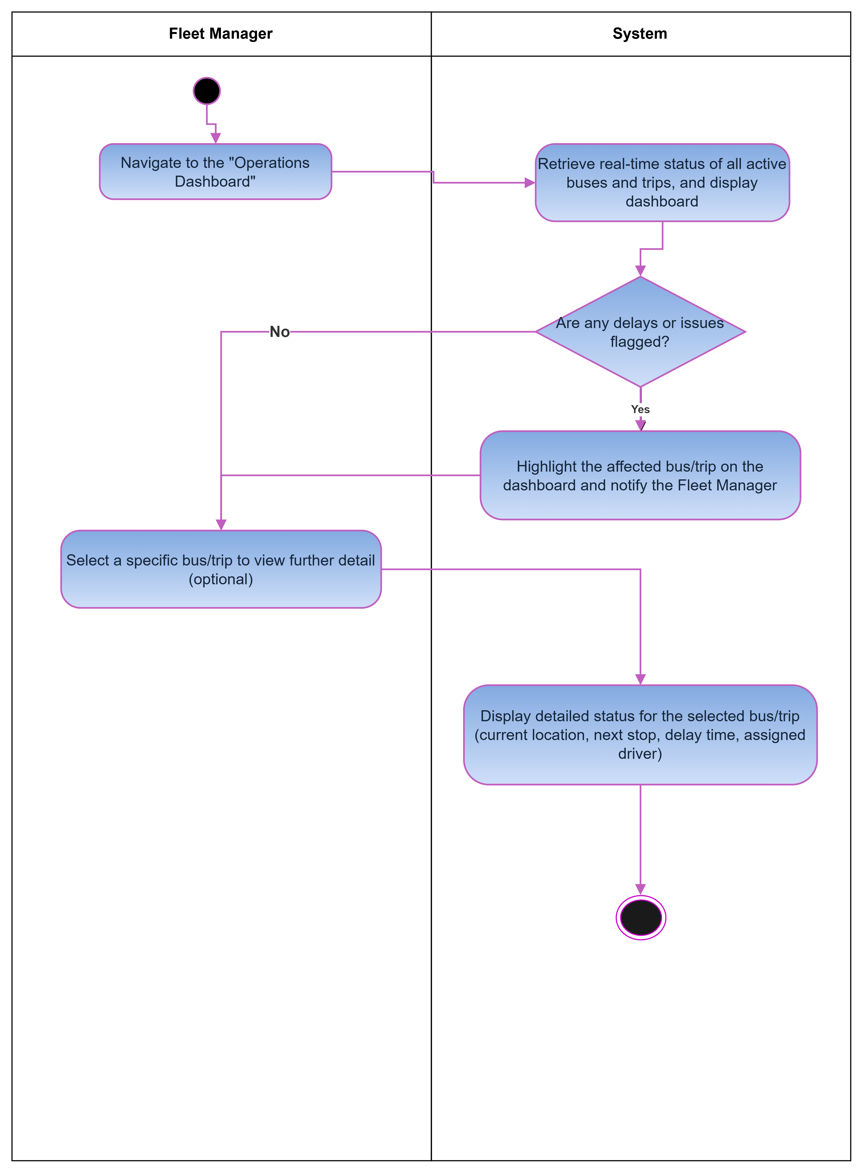

View Routes Use Case Narrative
BusNova
Use Case Specification
Use Case Id | UC13
User Case Name | View Routes
Actor(s) | Passenger
Brief Description | The views available bus routes, departure times, arrival times and trip information
Frequency of use | Whenever a passenger wants to check available bus routes and trip information
Preconditions | He/she must be logged on to the system
Main Flow of Events | Actor |  | System
Main Flow of Events | 1. Selects “View Routes” |  | 1.1. Redirects user to “View Routes” Page  1.2. Displays available bus routes and trip information
Alternative Flows of Events | If user entered wrong credentials the systems display validation error message on the login screen
Postconditions | The passenger has successfully logged into the system and taken to their dashboard
Special Requirements | Passenger log in details must be valid for them to view available routes
Created by | Olebogeng Gumbu | Last Modified by
Date | 22 August 2026 | Date

View Routes Activity Diagram
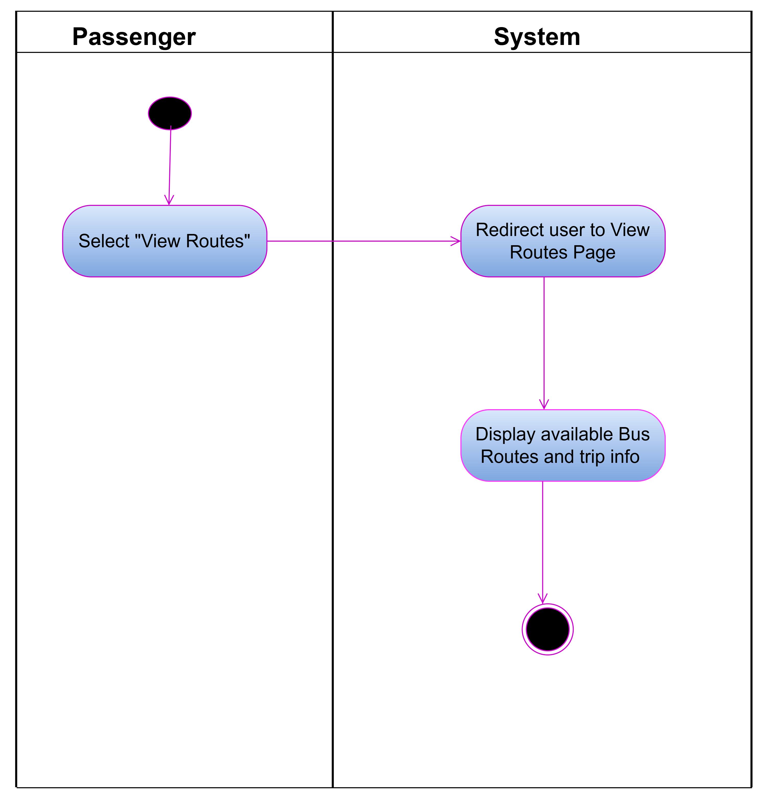

Report Fuel Use Case Narrative
BusNova
Use Case Specification
Use Case Id | UC10
User Case Name | Report Fuel
Actor(s) | Driver
Brief Description | Allows the driver to record the amount of fuel used by the assigned bus after or during a trip. The system stores the fuel usage information for monitoring and reporting.
Frequency of use | Daily after finishing all the trips.
Preconditions | 1. Driver is logged into the system.  2. Driver is assigned to the bus.  3. The bus exists in the system.
Main Flow of Events | Actor |  | System
Main Flow of Events | - Selects ‘Report fuel”  - Selects the assigned bus  - Enters fuel usage (in litres)  - Enters the trip details  - Clicks Submit |  | 1.1 Display fuel reporting form  5.1 Validates the entered information  5.2 Saves the fuel usage record  5.3 Updates the bus fuel usage  5.4 Displays confirmation message
Alternative Flows of Events | 1.Fuel usage is missing or invalid - The system displays an error message.  2.The submitted value is unrealistic (e.g., negative) - The system requests a valid value.
Postconditions | 1.Fuel usage record is stored.  2.Bus fuel usage history is updated.
Special Requirements | -Fuel usage must be entered in litres and must be a positive numerical value.  -The system must automatically record the date and time of the fuel usage report.  -The system must identify the logged-in driver and the bus assigned to them.  -The system must validate all entered information before saving the fuel usage record.  -Only authorised drivers may submit fuel usage reports.
Created by | Yonwaba Mqulwana | Last Modified by
Date | 24/08/2026 | Date

Report Fuel Activity Diagram
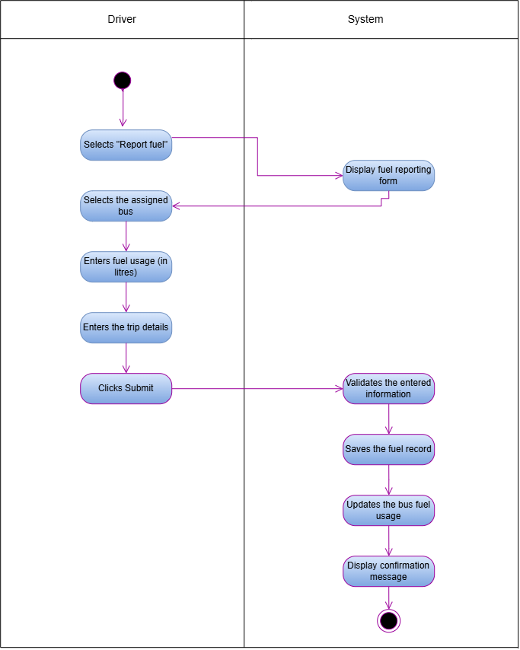

Log Servicing Activities Use Case Narrative
BusNova
Use Case Specification
Use Case Id | UC18
User Case Name | Log servicing Activities
Actor(s) | Maintenance staff
Brief Description | Maintenance staff logs details of a completed service/repair on a bus; the system saves the record and updates the bus's service history.
Preconditions | 1.Maintenance staff is registered and logged into the system  2.The bus to be serviced exists in the system.  3.The maintenance staff has been assigned access to the maintenance/service logging module.
Main Flow of Events | Actor |  | System
Main Flow of Events | 1.Selects “Log service activity”  2.Selects the bus that was serviced.  3.Enters the service details  4.Clicks Save Records |  | 1.1. Displays the log service activity form.  2.1. Displays the bus’s maintenance history.  4.1. Validates the required fields.  4.2. Saves the service record to maintenance log.  4.3. Updates the bus’s condition and next service due date.  4.4. Displays a confirmation message: “Service activity logged successfully.”
Alternative Flows of Events | 4.1.1. If required fields are missing or invalid, the system displays an error message and returns the maintenance staff to the form.  4.1.2. If the next service due date entered is earlier than the service date, the system displays a validation error and prompts for a correct date.
Postconditions | 1. Service record (service type, work carried out, service date, next service due date) is saved to the bus’s maintenance log.  2. Bus's vehicle condition status is updated to reflect the completed service.  3. Bus's next service due date is updated in the system.  4. Confirmation message is displayed.  5. Maintenance history is updated for future reference.
Special Requirements | -Required fields must be validated before saving.  -Next service due date must be later than the service date.  -Service records must be saved reliably (no data loss).
Created by | Anesipho Kalazana | Last Modified by |  | Yonwaba Mqulwana
Date | 23 August 2026 | Date |  | 25 August 2026

Log Servicing Activities Activity Diagram
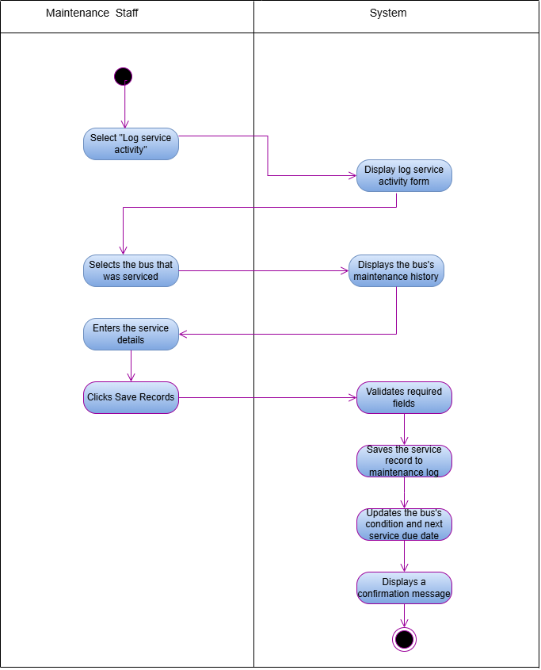

Purchase Ticket Use Case Narrative
BusNova
Use Case Specification
Use Case Id | UC15
User Case Name | Purchase Ticket
Actor(s) | Passenger
Brief Description | The passenger picks a route, enters their details, pays and the system checks seat availability, processes the payment and generates the ticket.
Frequency of use | High, whenever a passenger wants to book a trip.
Preconditions | 1.Passenger has a registered account and is logged into the system.  2. The selected route and trip have at least one available seat.
Main Flow of Events | Actor |  | System
Main Flow of Events | 1. Selects a route and checks availability for a trip.  2. Clicks “Purchase Ticket” for the desired trip.  3. Enters passenger details and selects a seat.  4.Enters payment details.  5.Clicks “Pay & Confirm”. |  | 1.1 Displays available trips and seat availability.  2.1. Displays the purchase ticket form.  5.1 Validates the payment details.  5.2 Confirms that the selected seat is still available.  5.3. Processes the payment  5.4. Generates the ticket and saves the record.  5.5. Displays a booking confirmation and sends a confirmation email to the passenger.
Alternative flow of events | 5.1.1. If the payment fails, the system displays an error message and prompts the passenger to retry or use a different payment method.  5.2.1. If the selected seat becomes unavailable before payment is confirmed, the system notifies the passenger and returns them to seat selection.
Postconditions | A ticket record is created and stored in the database, seat availability for the trip is updated, and the passenger receives a booking confirmation.
Special requirements | Payment details must be processed securely, seat availability must be validated in real time to prevent double booking, and each ticket must be assigned a unique ticket number.
Created by | Anesipho Kalazana | Last Modified by
Date | 24 August 2026 | Date

Purchase Ticket Activity Diagram
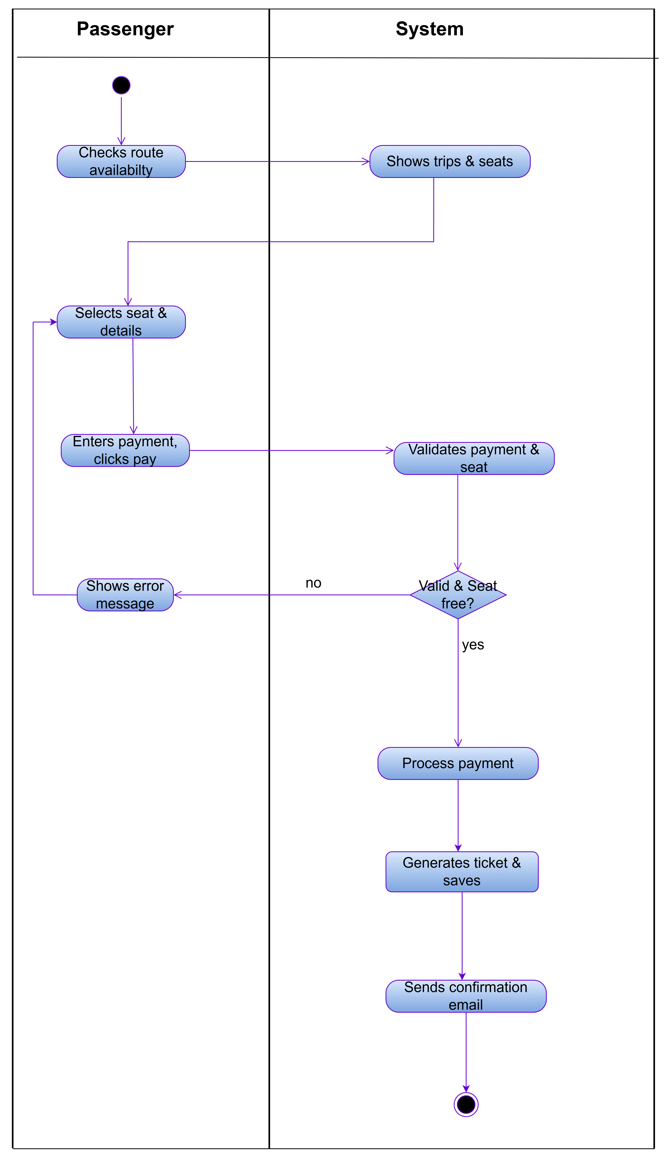

Check availability Use Case Narrative

Cyber nova
Use Case Specification
Use Case Id | UC14
User Case Name | Check availability
Actor(s) | Passenger
Brief Description | This use case allows a passenger to check the availability of buses by entering the departure location, destination and travel date. The system validates the information, checks available seats and displays the available bus options.
Frequency of use | High – whenever a passenger wants to check available buses before making a booking.
Preconditions | 1. The bus booking system must be available.  2. The passenger must have access to the system.  3. Bus schedules and seat availability must be available in the system.
Main Flow of Events | Actor |  | System
Main Flow of Events | 1. Selects “Check availability”.  2 Enters the departure location, destination and travel date.  3. Views the availability results.  4. Selects an available bus. |  | 2.1 Validate search details  3.1. Displays the book ticket option for an available bus.  4.1. Allows the passenger to proceed to booking.  4.2. Ends the Check availability use case.
  1.1. Displays the search form.
  2.2 Checks the availability of buses and seats
  based on the search details.
Alternative Flows of Events | 1.If invalid details are entered, the system will show an error message and prompt the passenger to correct them.  2.If no seats or no buses are found, the system will display a "No seats available" or "No buses available" message and allow the passenger to search again with new details
Postconditions | 1.Available buses and seats are displayed, allowing the passenger to select a bus and proceed to booking.  2. If no seats or buses are available, the system displays an appropriate message.
Special requirements | 1.The system must verify the departure location, destination, and travel date, provide current, correct bus, and seat availability, and ensure fast search responses.  2.It must also keep passenger details secure during the search and offer a simple, user-friendly experience on all supported devices.
Created by | Esethu Mtose | Last Modified by
Date | 23/08/2026 | Date

Check availability activity diagram

Report Issues Use Case Narrative

Bus Nova
Use Case Specification
Use Case Id | UC11
User Case Name | Report Issues
Actor(s) | Driver
Brief Description | The Report Issue use case allows drivers to report problems identified while operating or inspecting a bus. The driver provides information about the issue, such as the bus, issue type, description, and severity. System stores the report in the centralised database and makes the information available to Maintenance Staff for follow-up and maintenance.
Frequency of use | As required, whenever a Bus Driver identifies an issue with an assigned bus. This may occur multiple times per day across the entire fleet, depending on vehicle conditions and operational activities.
Precondition | Driver must be registered in the system.  Driver must be authenticated and logged into the system.  Driver must have an assigned bus.
Main Flow of Events | Actor |  | System
Main Flow of Events | 1. Select “Report issues”  2. Enter the issue details  3. Submit issue |  | - Display Report Form  3.1 Save the issue  3.2 Display Confirmation message
Alternative Flows of Events | The Driver attempts to submit the issue report without completing all required fields.
Postconditions | An issue reference number is generated.  Maintenance Staff can view and manage the reported issue.  The issue status is set to Reported.
Special requirements | Only registered and authenticated Bus Drivers should be allowed to report issues.  The system should prevent loss of issue reports and maintain accurate records even when multiple Drivers are reporting issues simultaneously
Created by | Elihle Nteyi | Last Modified by |  | Yonwaba Mqulwana
Date | 30 August 2026 | Date |  | 30 August 2026

Report Issues Activity Diagram

2.Section B: Data Modelling Requirements

2.1. Entity Relationship Diagram
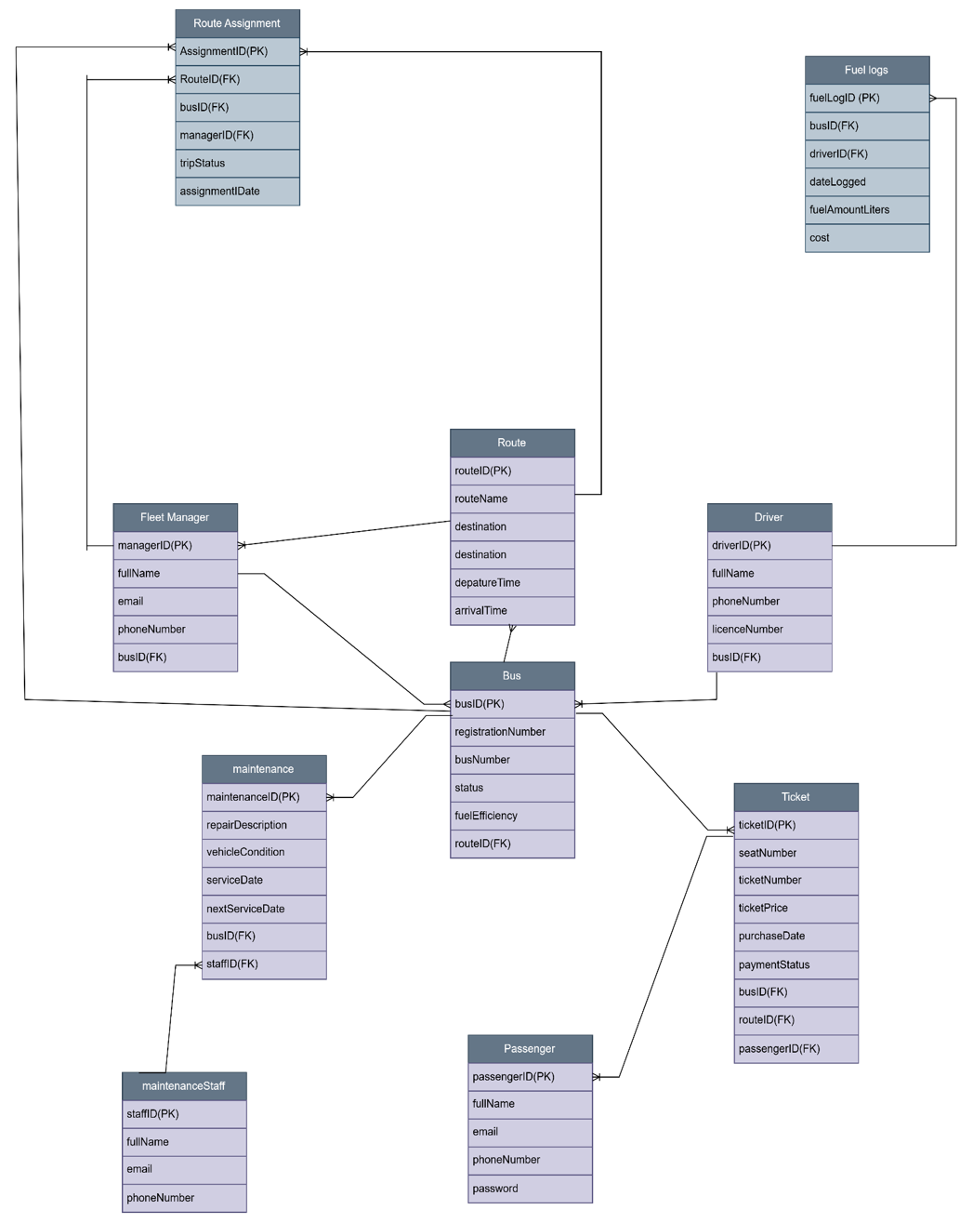Figure 9: BusNova Entity Relationship Diagram

2. 2. Attribute Framing

2.2.1. Fleet Manager
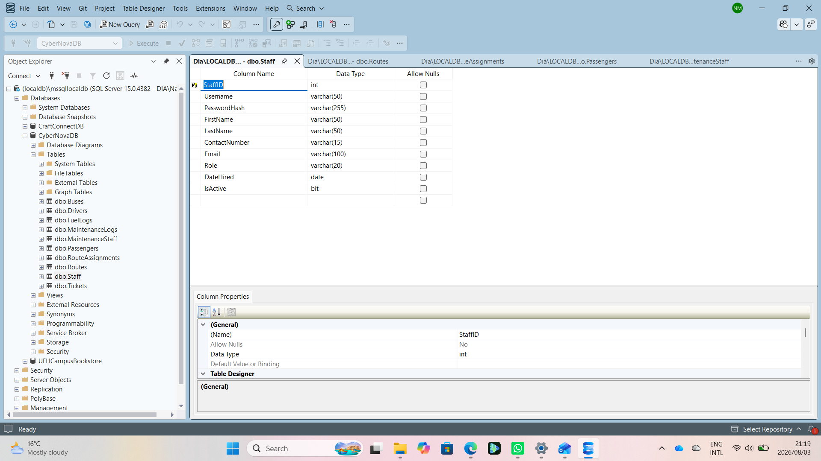
Figure 10: Fleet Manager

2.2.2. Passengers
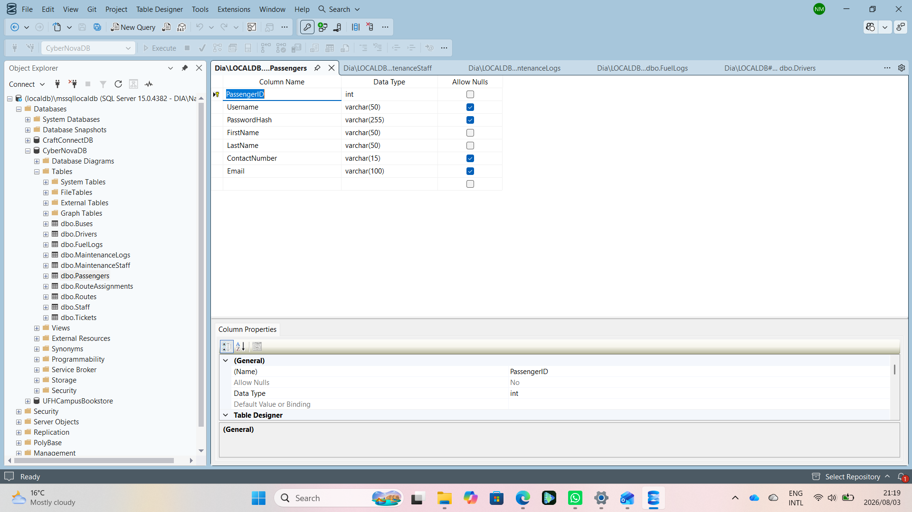
Figure 11: Passengers

2.2.3. Drivers
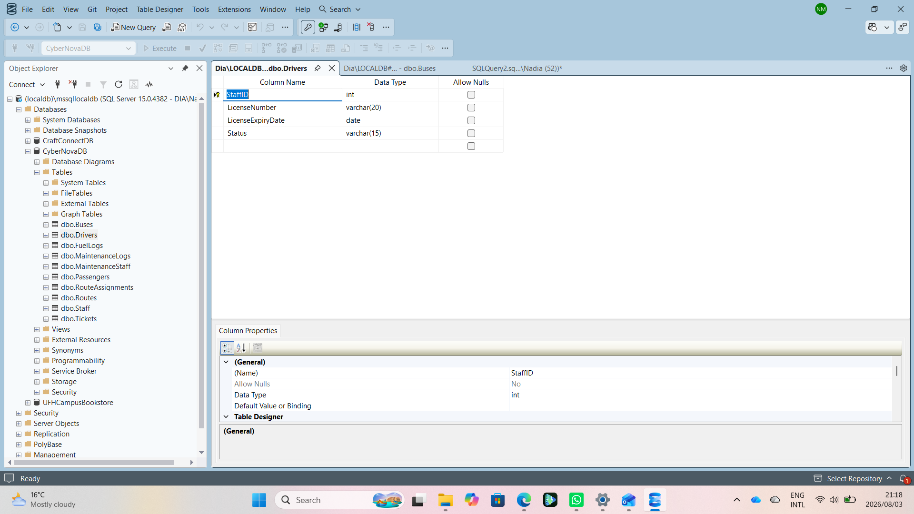
Figure 12: Drivers

2.2.4. Maintenance Staff
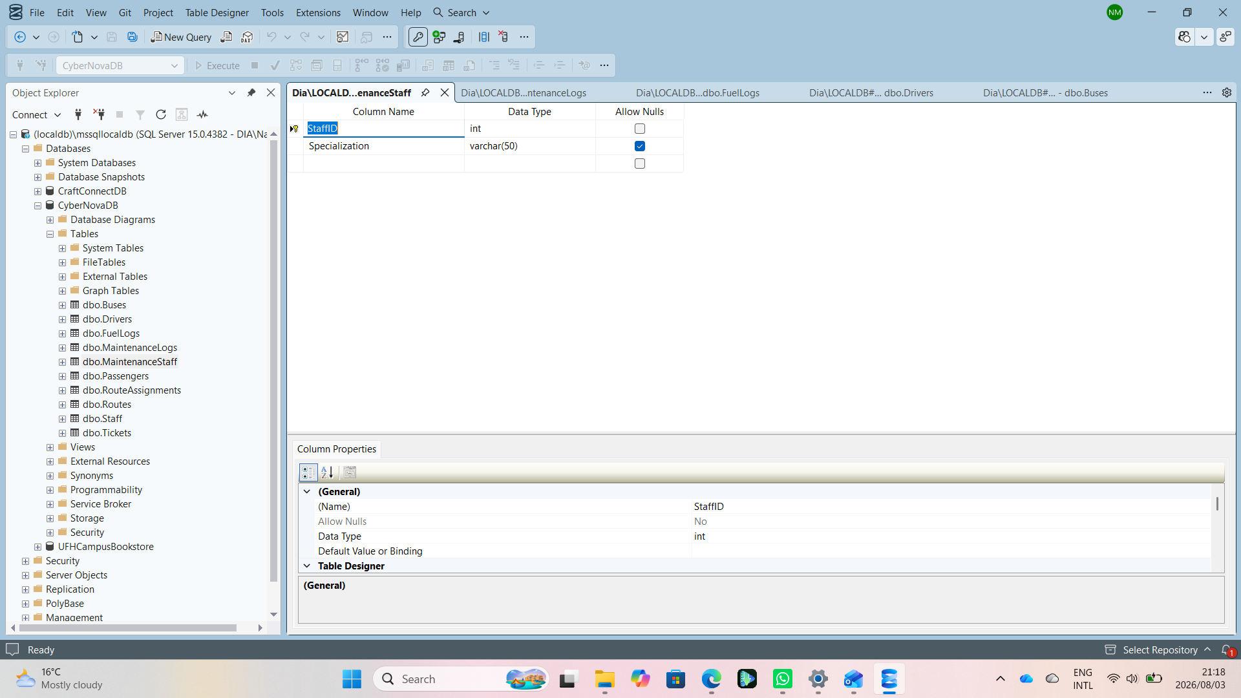
Figure 13: Maintenance Staff

2.2.5. Buses
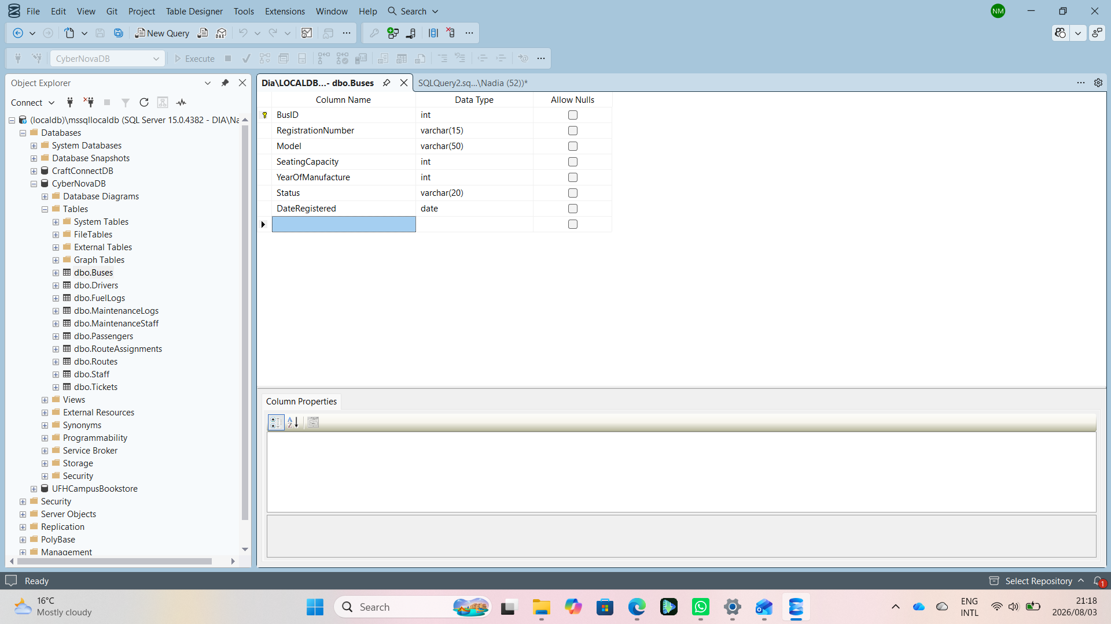
Figure 14: Buses

2.2.6. Routes
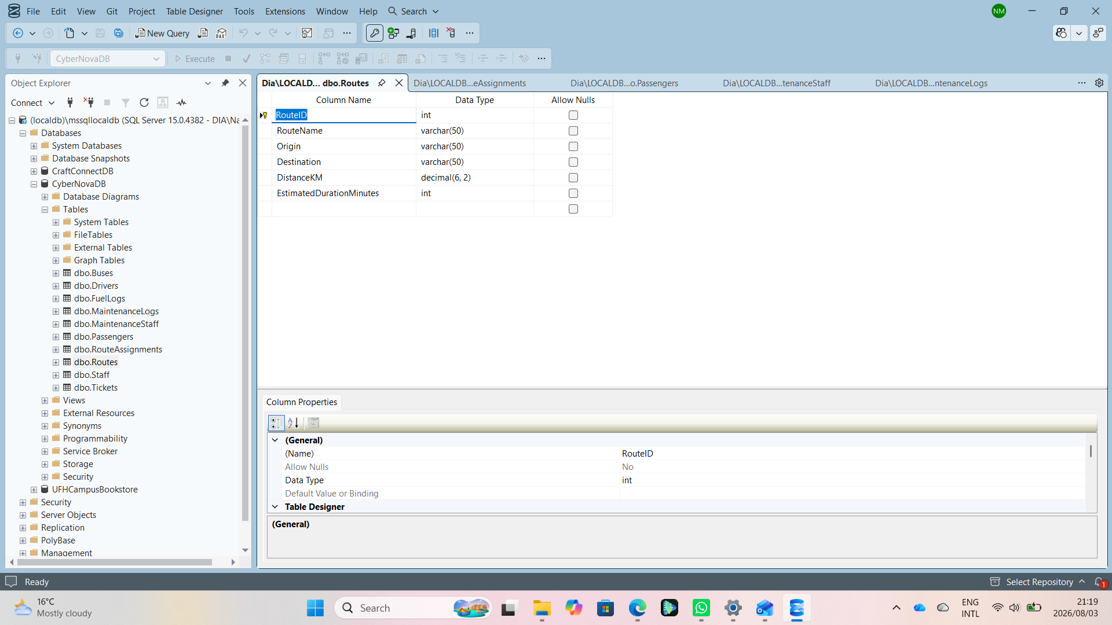
Figure 15: Routes

2.2.7. Route Assignments
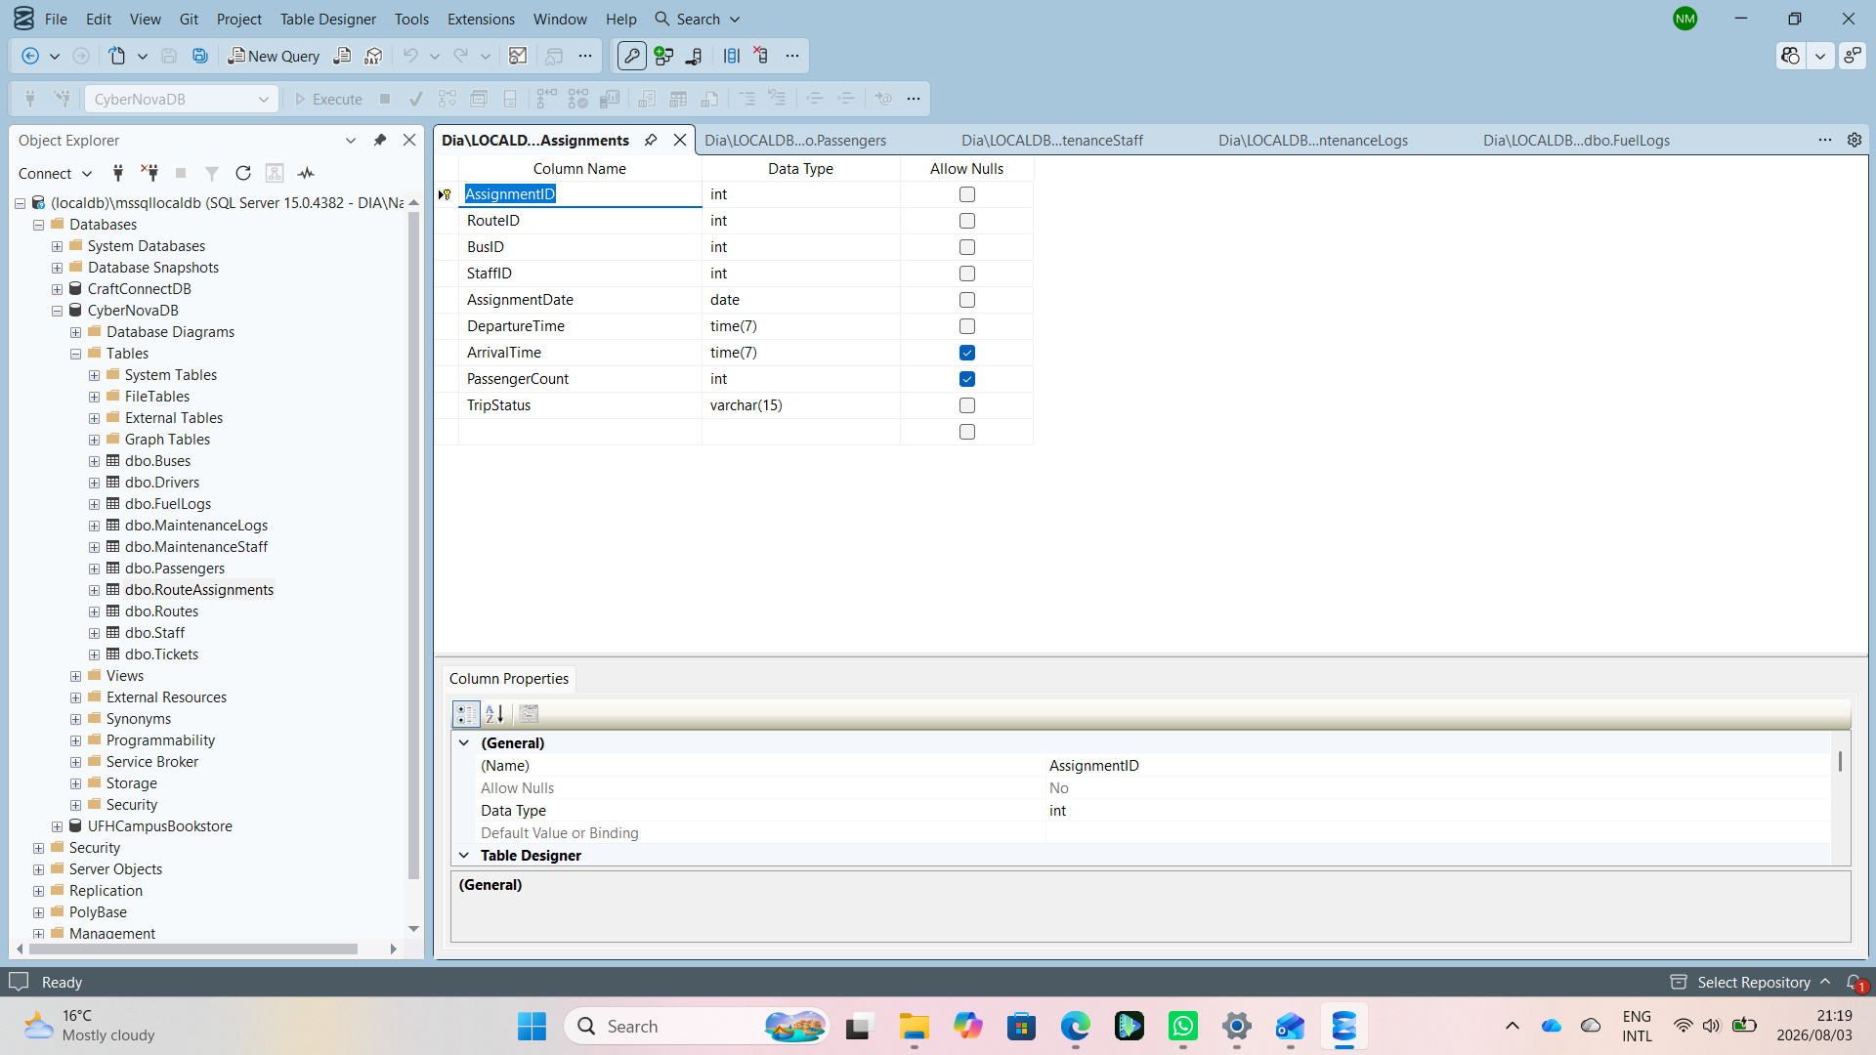
Figure 16: Route Assignments

2.2.8. Maintenance Logs
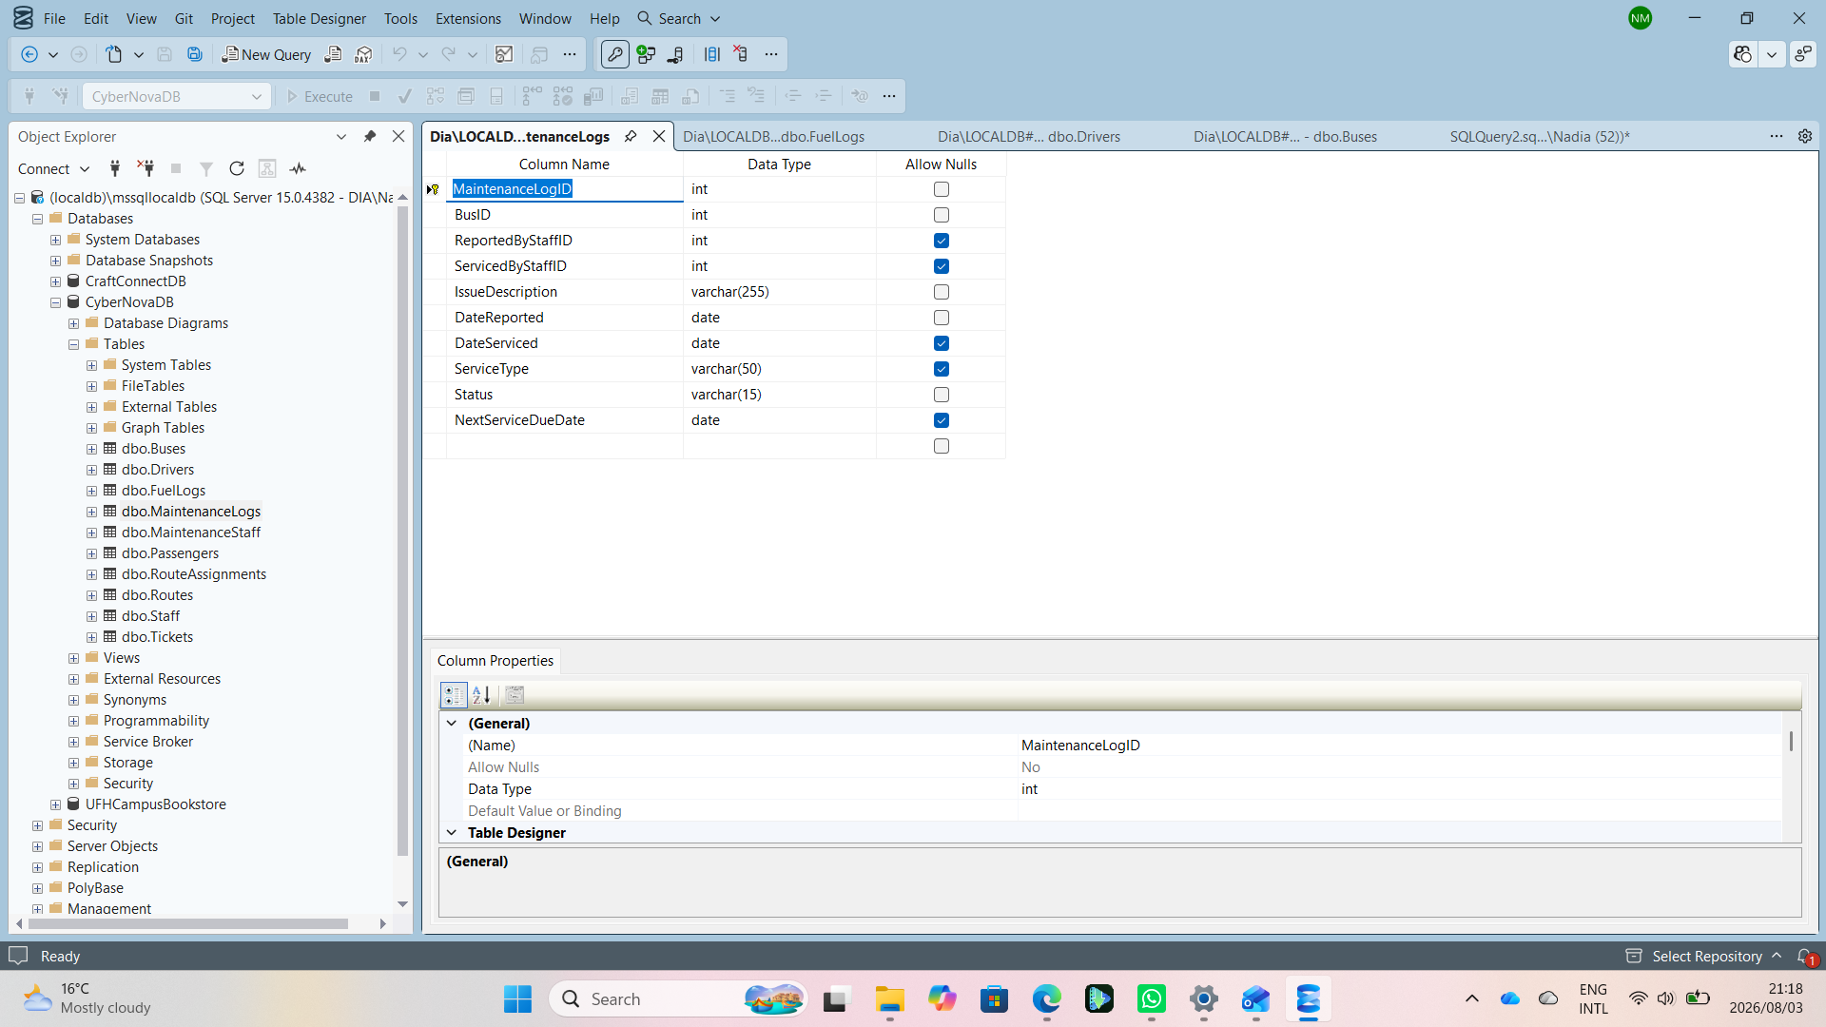
Figure 17: Maintenance Logs

2.2.9. Fuel Logs
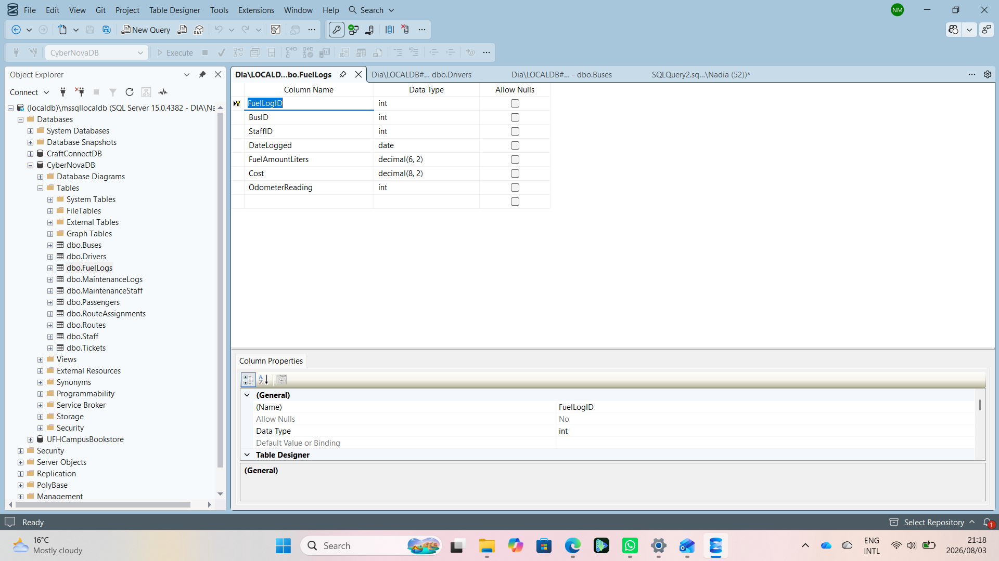
Figure 18: Fuel Logs

2.2.10. Tickets
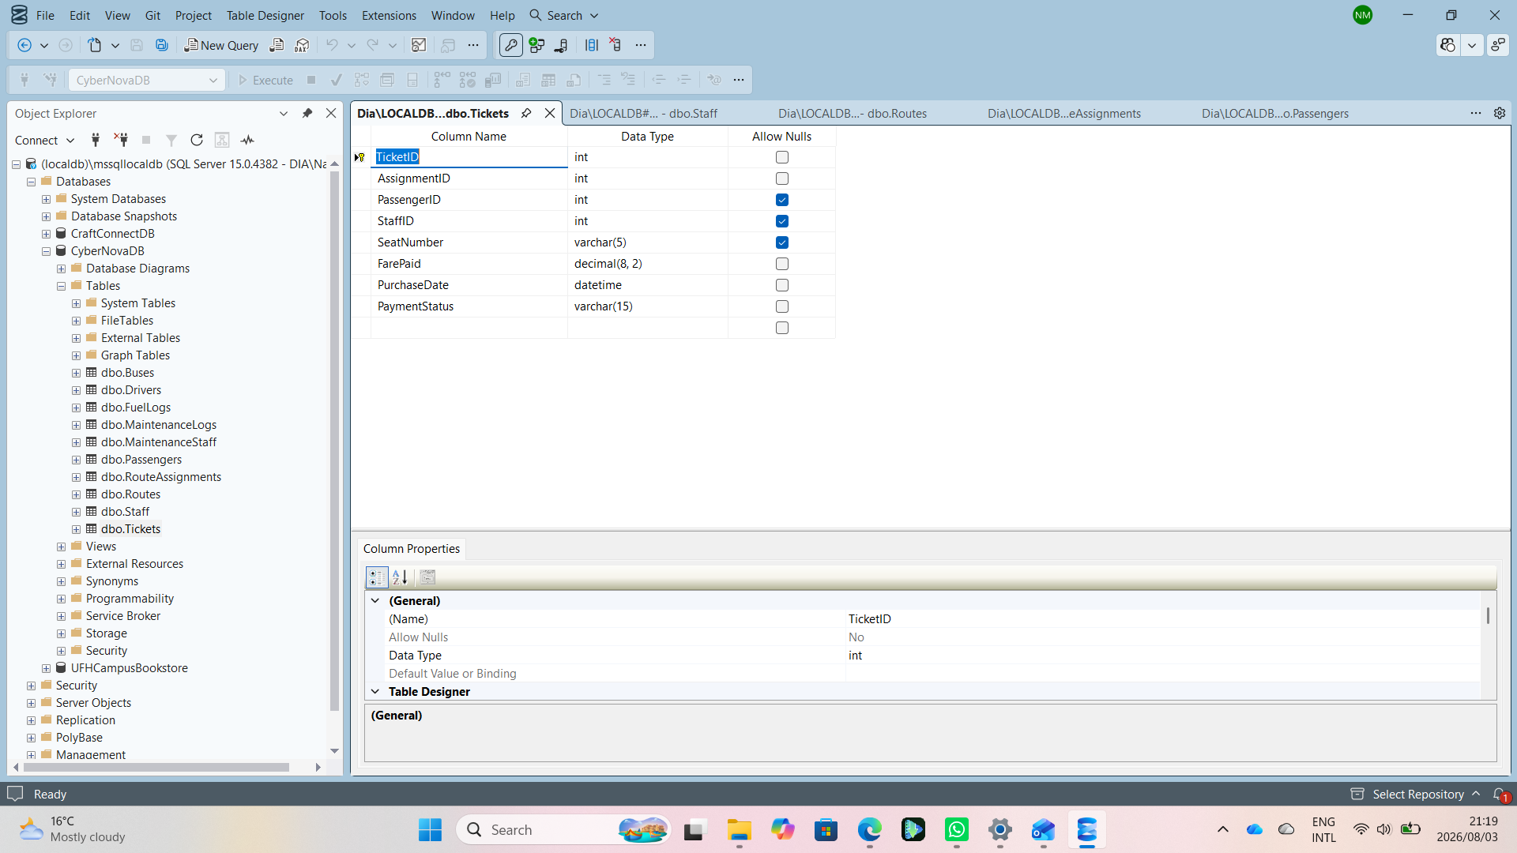
Figure 19: Tickets

3.Section C: Systems Design Requirements

3.1. Windows Navigation Diagram
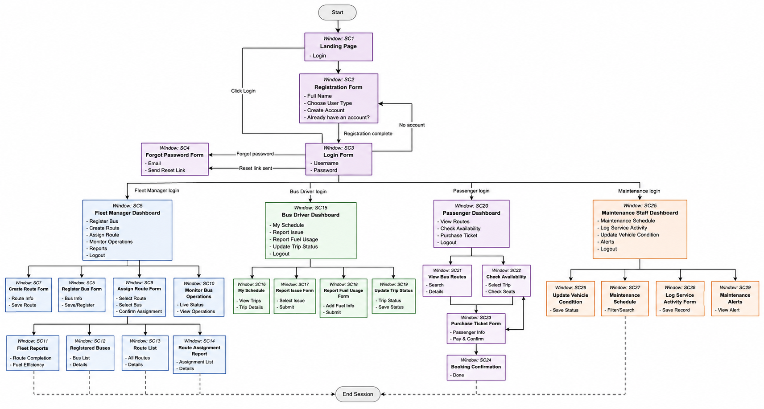Figure 20: BusNova Windows Navigation Diagram

3.2. Screen Design Specification

3.2.1. Screen 01: Home Page
The Home Page serves as the main entry point to the BusNova System. It introduces users to the system and provides navigation options to access the relevant functionality. Users can select Get Started, Login, or Register to proceed to the appropriate part of the system.
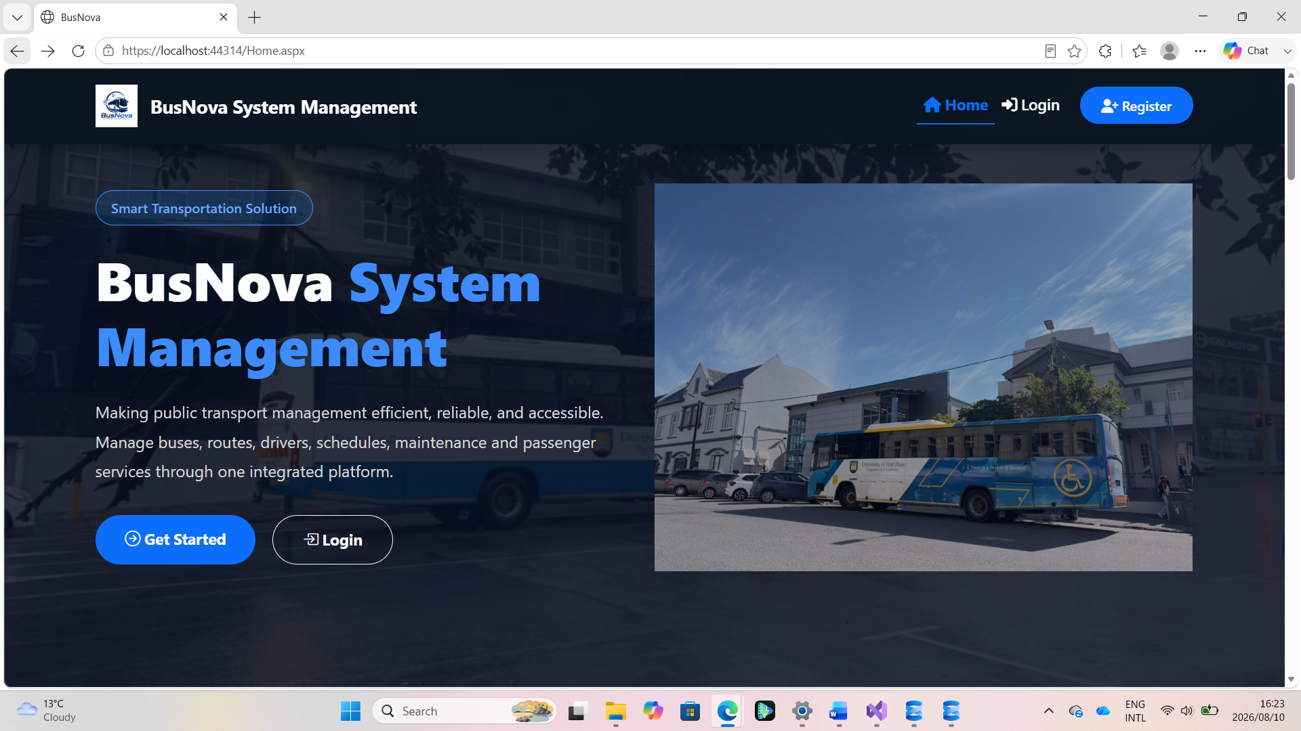Figure 21: Home Page Screen

Screen Narrative and Controls: SC1
Reference | Control Type | Data Input | Data Output
CR1 | Button | Click | Login page
CR2 | Button | Click | Register page
CR3 | Image |  | Bus image
CR4 | Image |  | Background bus image
Table 9: SC1 - Screen Narrative and Controls

3.2.2. Screen 02: Register
The Register screen allows new users to create a BusNova account by entering their personal and account information, including their name, username, email address, contact number and password. The user also selects their appropriate system role during registration. The information provided is used to create the user's account and enable authenticated access to the system.
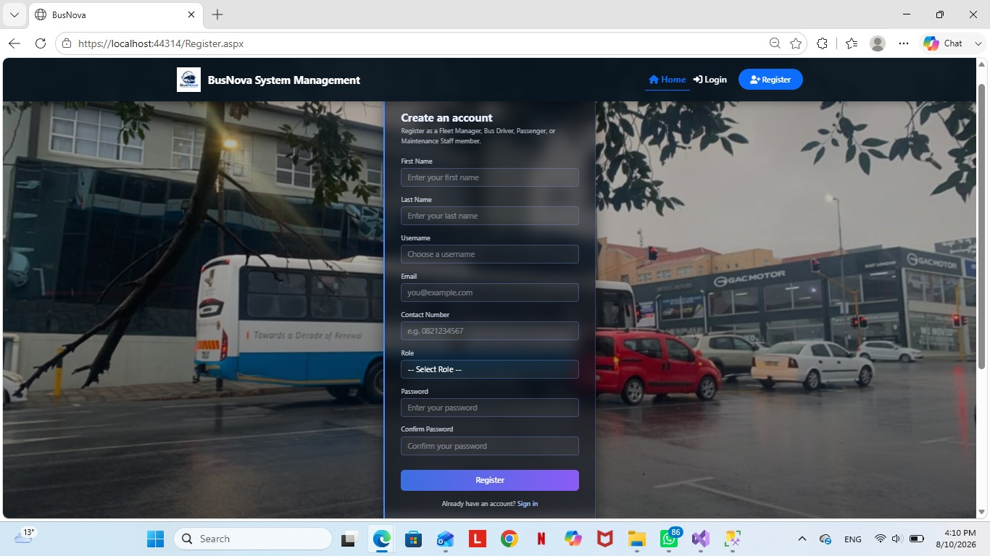Figure 22: Register Screen

Screen Narrative and Controls: SC2
Reference | Control Type | Data Input | Data Output
CR1 | Textbox | User’s first name
CR2 | Textbox | User’s last name
CR3 | Textbox | Username
CR4 | Textbox | User’s email
CR5 | Textbox | Contact details
CR6 | Dropdown | Select a role | Role
CR7 | Textbox | User enters password
CR8 | Textbox | Confirms user’s password
CR9 | Button | Click | Login page
Table 10: SC2 - Screen Narrative and Controls

3.2.3. Screen 03: Login
The Login screen allows registered users to securely access the BusNova System by entering their email address and password. Upon successful authentication, the user is directed to the appropriate dashboard based on their assigned role.
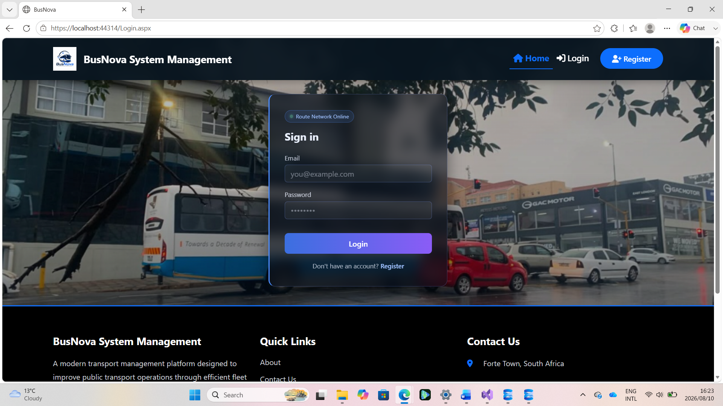Figure 23: Login Screen

Screen Narrative and Controls: SC3
Reference | Control Type | Data Input | Data Output
CR1 | Textbox | User’s email
CR2 | Textbox | User enters password
CR3 | Button | Click | Display dashboard

Table 11: SC3 - Screen Narrative and Controls

3.2.4. Screen 04: Register Bus
The Register Bus screen enables the Fleet Manager to add a new bus to the BusNova fleet by capturing details such as the registration number, model, manufacturer, seating capacity, fuel type and year of manufacture. The Register Bus button saves the bus information to the system.
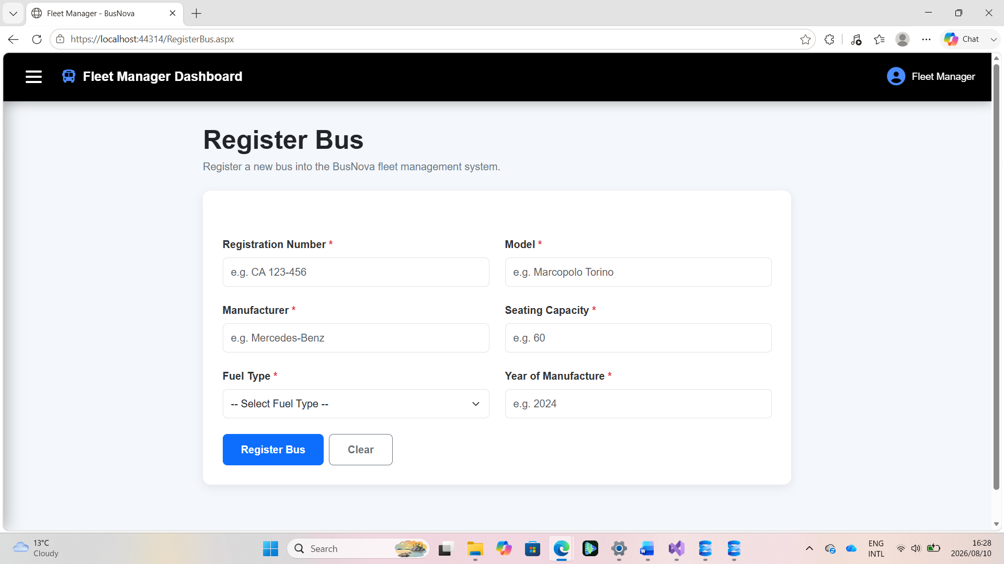Figure 24: Register Bus Screen

Screen Narrative and Controls: SC4
Reference | Control Type | Data Input | Data Output
CR1 | Textbox | Registration number
CR2 | Textbox | Bus model
CR3 | Textbox | Bus manufacturer
CR4 | Textbox | Seating capacity
CR5 | Dropdown | Select fuel type | Fuel type
CR6 | Textbox | Year of bus manufacture
CR7 | Button | Click | Register bus
CR8 | Button | Click | Clear the form
Table 12: SC4 - Screen Narrative and Controls

3.2.5. Screen 05: Create Routes
The Create Route screen enables the Fleet Manager to create a new bus route by entering the required route information, including the route name, origin, destination, distance and estimated travel time. The entered information is submitted to create and store the new route in the system.
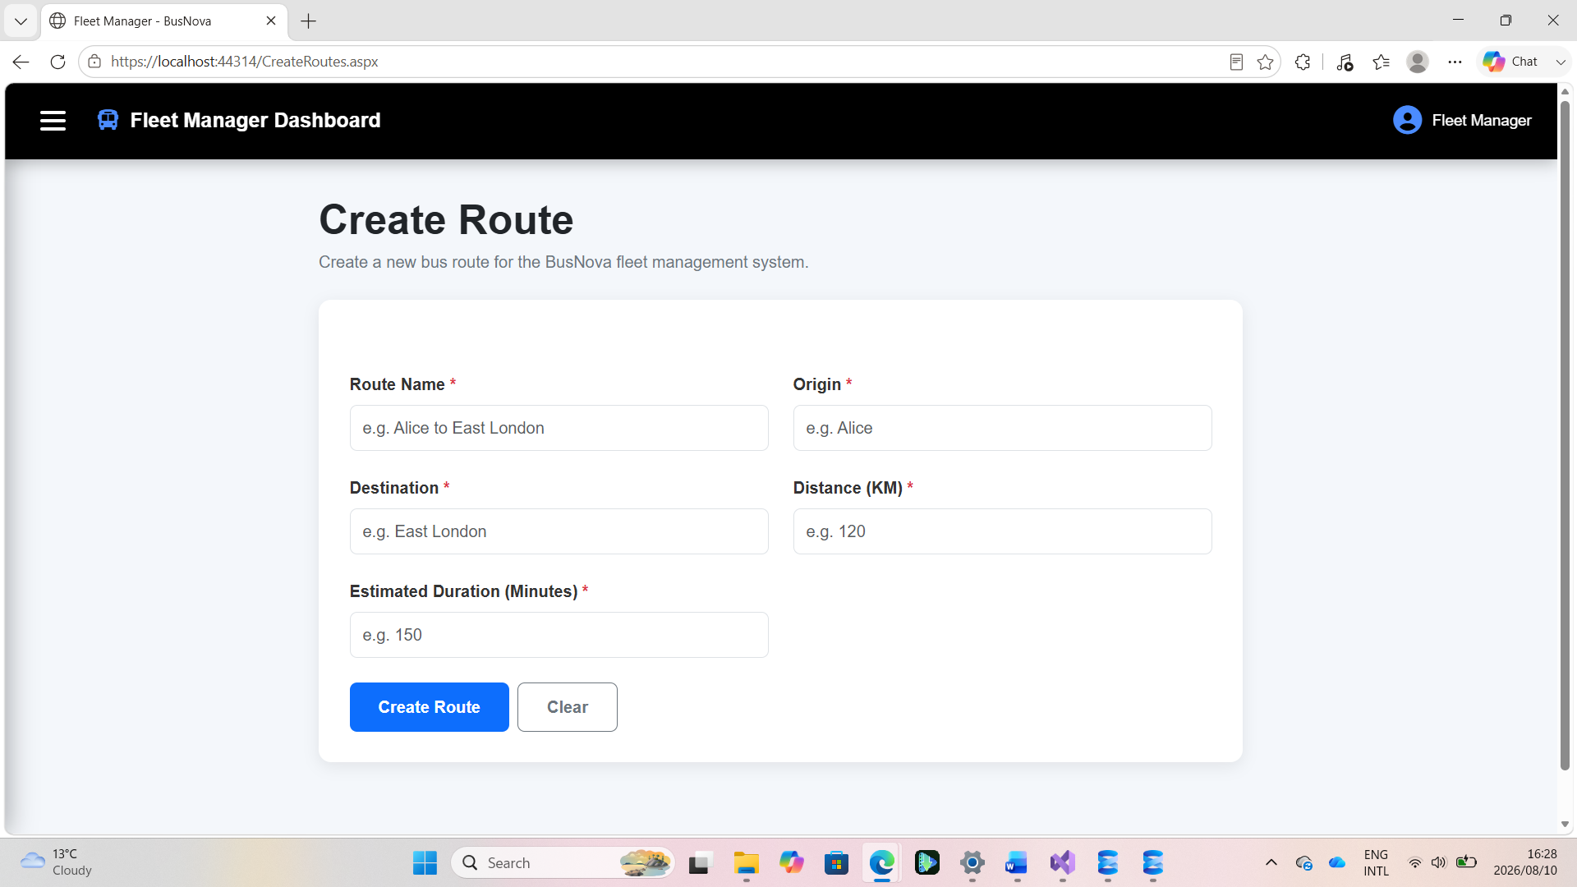Figure 25: Create Routes Screen
Screen Narrative and Controls: SC5
Reference | Control Type | Data Input | Data Output
CR1 | Textbox | Route name
CR2 | Textbox | Origin of route
CR3 | Textbox | Route destination
CR4 | Textbox | Distance in KM
CR5 | Textbox | Estimated duration in minutes
CR6 | Button | Click | Creates route
CR7 | Button | Click | Clear the form
Table 13: SC5 - Screen Narrative and Controls

3.2.6. Screen 06: Assign Routes
The Assign Routes screen enables the Fleet Manager to assign an available bus and driver to a selected route and schedule. The Fleet Manager provides the required assignment details, including the route, driver, bus, date and departure information, allowing the system to allocate resources to a specific trip.
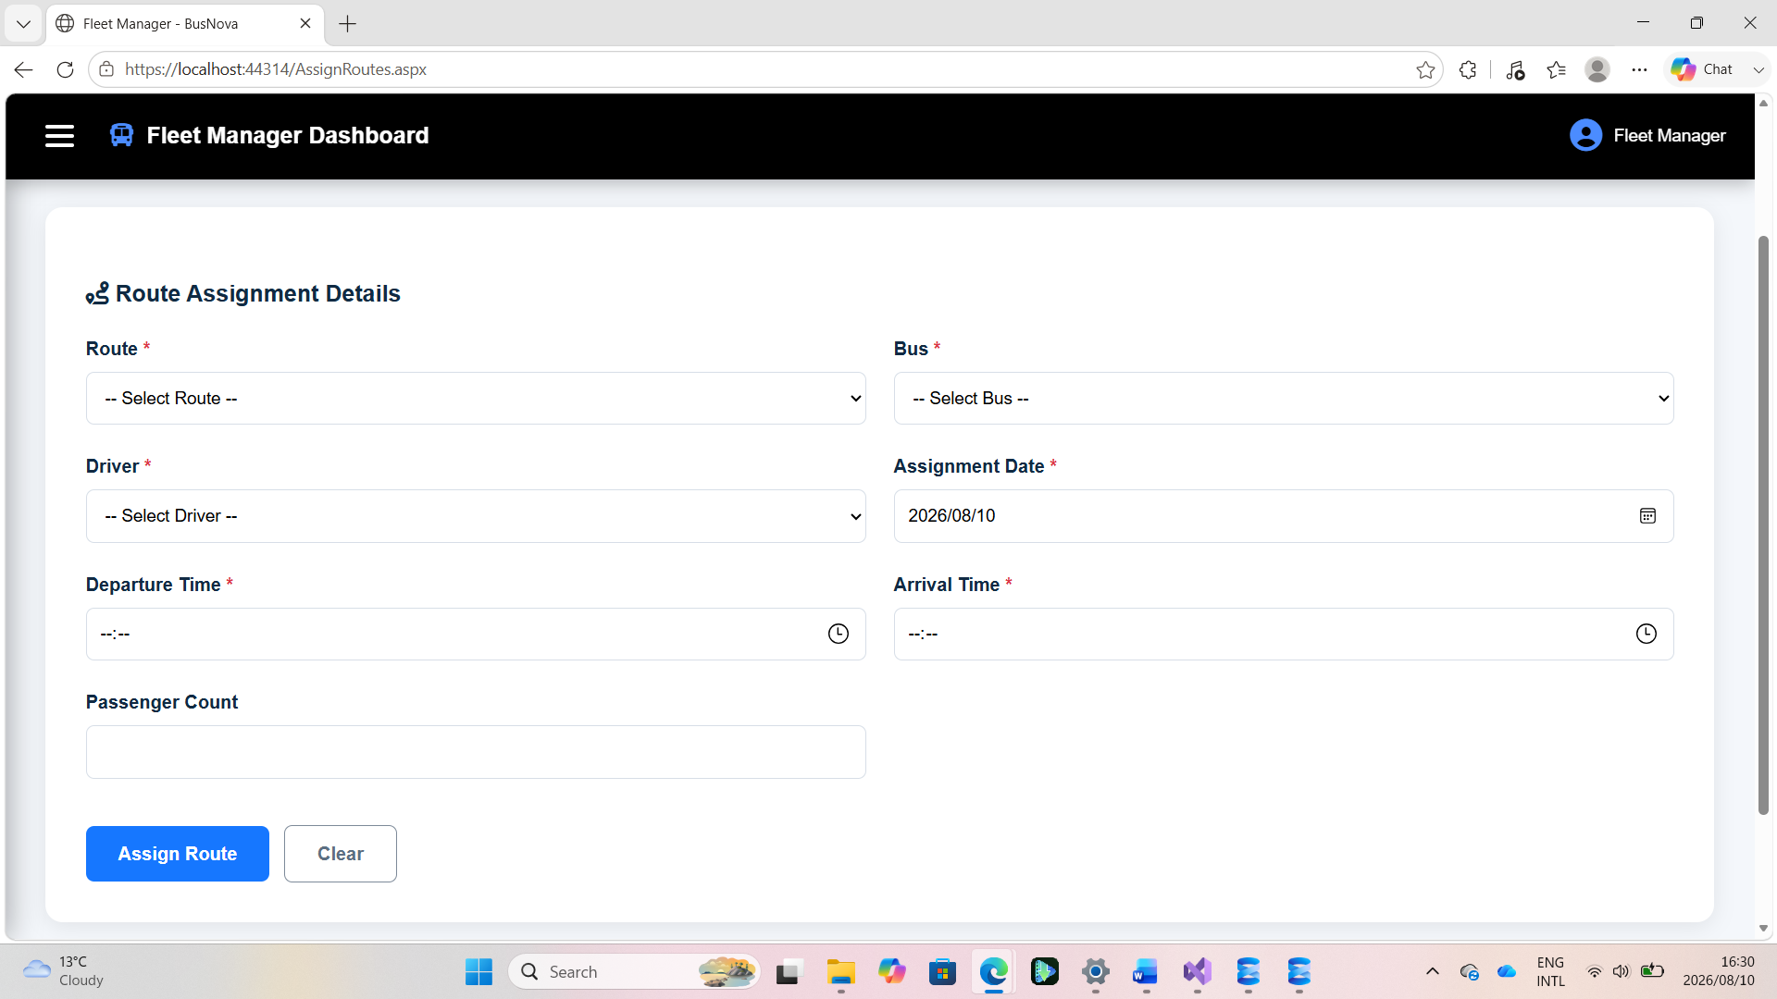Figure 26: Assign Routes Screen

Screen Narrative and Controls: SC6
Reference | Control Type | Data Input | Data Output
CR1 | Dropdown | Select route | Route
CR2 | Dropdown | Select a bus | Bus
CR3 | Dropdown | Select a driver | Driver
CR4 | Textbox | Assignment date
CR5 | Textbox | Departure time
CR6 | Textbox | Arrival time
CR7 | Textbox | Passenger count
CR8 | Button | Click | Assign route
CR9 | Button | Click | Clear the form
Table 14: SC6 - Screen Narrative and Controls

3.2.7. Screen 07: View Assigned Routes
The View Assigned Routes screen allows the Bus Driver to access their assigned routes and trip schedules. It displays important trip information, including the assigned route, bus, date, departure and arrival times, passenger count and current trip status, enabling the driver to monitor their scheduled transportation duties.
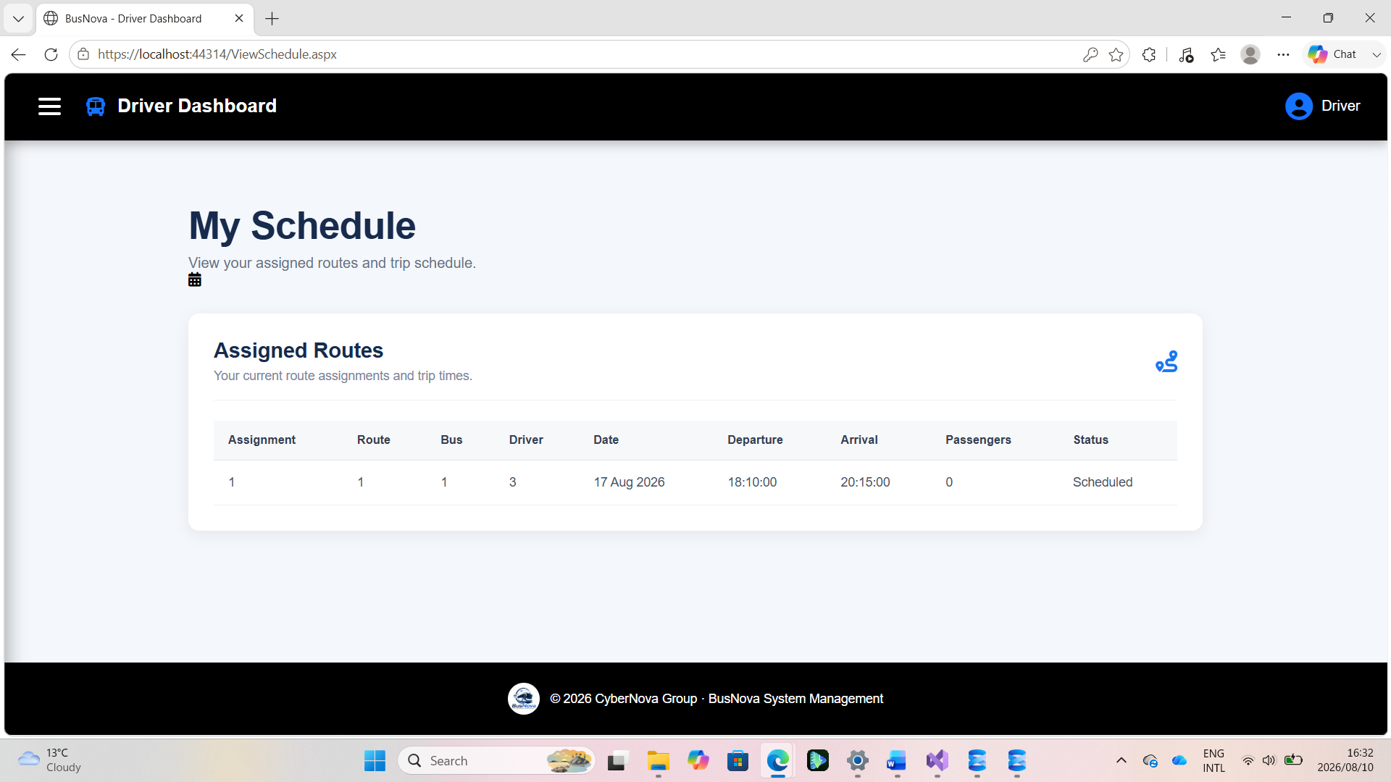Figure 27: View Assigned Routes Screen

Screen Narrative and Controls: SC7
Reference | Control Type | Data Input | Data Output
CR1 | Grid view | Display assigned route
Table 14: SC7 - Screen Narrative and Controls

Sprint Backlog - Sprint 1
Requirement | Sub Tasks | Dependency | Estimated  Completion  Time (in days) | Responsible  Group Member
1.Business  Process  Description | 1.1 Identify actors and business processes | none | 1 day | Nadia  Mpohlekana
 | 1.2 Create  System Matrix | Identify actors and business processes | 1 day | Olebogeng  Gumbu
 | 1.3 Develop Use  Cases | Create System  Matrix | 2 days | Esethu Mtose
 | 1.4 Write Use  Narratives | Developed use cases | 2 days | Anesipho  Kalazana
 | 1.5 Create  Activity  Diagrams | Use Case  Narratives | 2 days | Yonwaba  Mqulwana
2.Data  Modelling | 2.1Identify entities and attributes | System matrix | 1 day | Elihle Nteyi
 | 2.2 Create ERD | Entity identification | 2 days | Esethu Mtose
 | 2. 3 Create  Attribute  Framing | ERD complete | 1 day | Olebogeng  Gumbu
 | 2.4 Generate  SQL database creation script | Attribute framing complete | 2days | Nadia  Mpohlekana
3.System Design requirements | 3.1UML Window  Navigation  Diagram | Activity Diagrams completed | 2 days | Elihle Nteyi
 | 3.2 Screenshots | UML Window  Navigation  Diagram | 1 day | Simanye  Siximba
 | 3.3 Screen narratives and controls | System Screens (Screenshots) completed | 1 day | Simanye  Siximba
4.Documentation | Review sprint 1 document | All tasks completed | 3 days | All members

Risk Log

Ref  No | Description | SQERT | Probability | Impact | Criticality | Proximity | Author | Mitigation  and owner | Date  Raised | Date  Updated | Current  Status | Date  Closed
1 | Database changes made by one team member causing compatibility problems for other team members | ST | 3 | 4 | 12 | During collaborative development | Team Members | DB Developer | 31/07/2026 | 08/08/2026 | Reducing | Not closed
2 | Insufficient system testing before submission | T | 3 | 5 | 15 | During final testing | Team Members | Testing Member | 01/08/2026 | 08/08/2026 | New | Not closed
3 | Loss or corruption of project files or database due to inadequate backups | QER | 2 | 5 | 10 | Throughout development | Team Members | Technical Lead | 02/08/2026 | 08/08/2026 | Reducing | Not closed

KEY: SQUERT
Code | Meaning
S | Scope
Q | Quality
E | Effort
R | Resources
T | Time

Sprint Progress Report
Project Name:  BusNova Bus Management System | Sprint Number:  Sprint 1
Sprint Duration:  13 July 2026 - 11 August 2026 | Report Date:  11 August 2026
Report Number:  1 | Prepared By:  Nadia Mpohlekana

Sprint Goals | Goal 1: Analyse the business processes of the BusNova system and finalise the functional and non-functional requirements.  Goal 2: Produce a complete UML design blueprint for the system, including use case, activity, and structural diagrams.  Goal 3: Establish the technical foundation of the system by implementing the SQL Server database and an initial connected user interface.
Completed Work in line with Sprint Backlog | Task 1: Requirements and System Analysis - Completed  Task 2: UML and System Design - Completed  Task 3: Database and User Interface Foundation - Completed
In-Progress Work | Task 1: Implementation of the remaining system modules using the completed UML designs.  Task 2: Development of business logic for user authentication, route management, booking processes, and administrative functions.  Task 3: Testing database connectivity, validating user interface functionality, and refining screen layouts.
Upcoming Work | Task 1: Implement the remaining CRUD functionality for all system entities.  Task 2: Conduct integration testing between the user interface and the SQL Server database.  Task 3: Prepare the system for Sprint 2 by implementing advanced functionality, improving usability, and resolving identified issues.
Blockers and Challenges | Blocker 1: Coordinating multiple documentation deliverables simultaneously required careful planning and communication among team members.  Blocker 2: Ensuring consistency across all UML diagrams and maintaining alignment with the business processes required several collaborative review sessions.  Blocker 3: Integrating the initial user interface with the SQL Server database presented minor configuration challenges, which were resolved through collaborative troubleshooting and testing.
Team Member Contributions | Nadia Mpohlekana - Responsible for the completion, structure, and quality of the Sprint Progress Report.  Yonwaba Mqulwana- Developed the Activity Diagrams and the System Matrix for the entire system.  Anesipho Kalazana- Authored the Use Case Narratives.  Esethu Mtose- Developed the Entity Relationship Diagram (ERD) and the Use Case Diagram.  Elihle Nteyi- Generated the Database script and developed the Windows Navigation Diagram.  Olebogeng Gumbu - Identified each system screen, detailing its contents and framing the required attributes.  Simanye Siximba- Built the user interface and implemented the database.
Velocity and Burndown Chart | Velocity:  The team achieved approximately 75% of the planned Sprint 1 deliverables. All planned design artefacts were completed successfully, with implementation activities commencing as scheduled.
Sprint Retrospective Summary | What Went Well:  All planned UML and design deliverables were completed on schedule.  What Didn't Go Well:  Coordinating parallel documentation work across multiple team members occasionally caused version and alignment issues.  Action Items for Improvement:  Introduce a shared review checkpoint before finalising diagrams to catch inconsistencies earlier.
Key Takeaways | Sprint 1 successfully established the full analysis, design, and technical foundation of the BusNova Bus Management System. With requirements confirmed, UML artefacts completed, and the database and UI foundation in place, the team is well positioned to move into full module implementation and integration testing in Sprint 2.
Prepared by | Nadia Mpohlekana
Role | Project Manager & Documentation Lead
Date | 11 August 2026
Table 15: Sprint Progress Report

